Nama : Anita Siagian

Be The Best Top Search Quality Engineer

1. Soal No 1

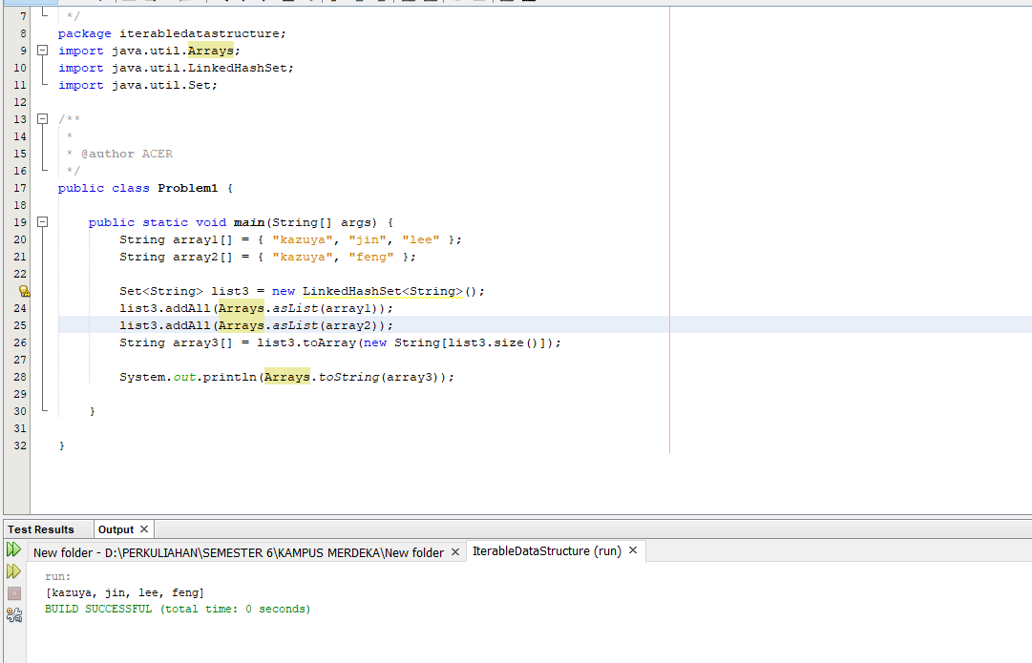

1. Soal No 2

-

1. Soal No 3
2. Soal No 4

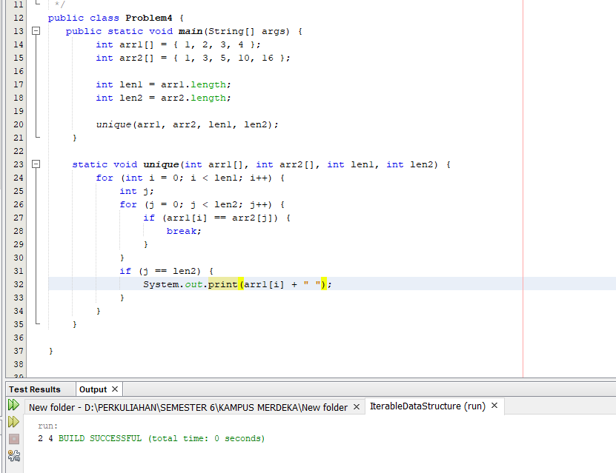

1. Soal No 5

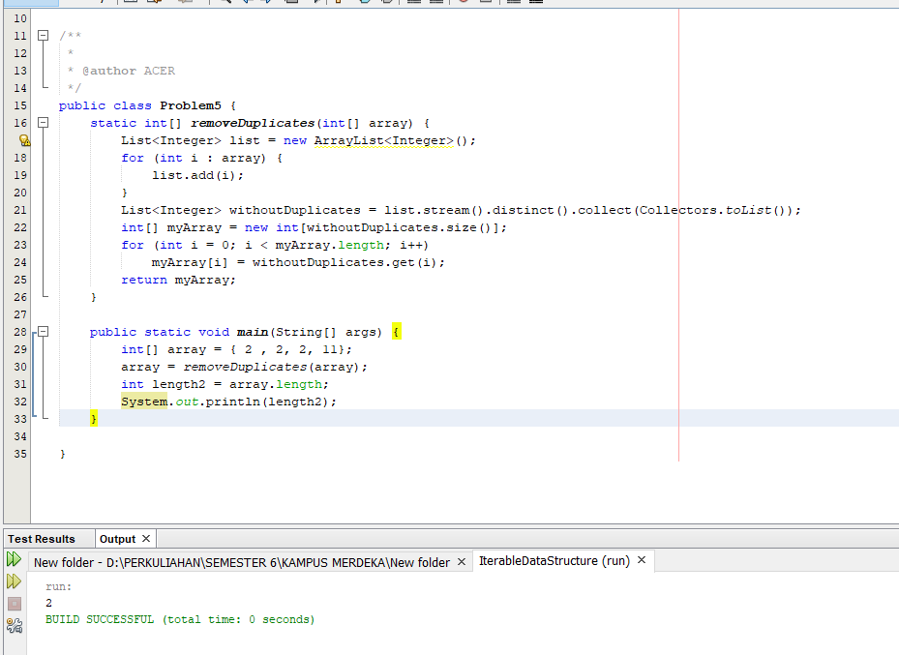

1. Soal No 6

